HUMAN BODY SYSTEMS ONLINE COLLABORATIVE PROJECT
Course: Anatomy and Physiology Instructor: Mr. Reed
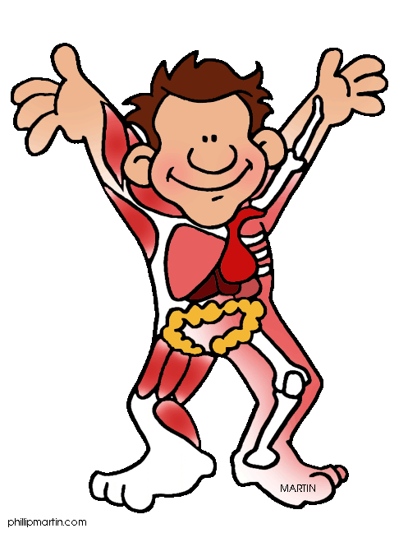

INTRODUCTION
For this project you will work with a partner and research an assignment aspect of one of the human body systems. You and your partner will be given 4 days to research and put together your presentation. You will present your findings to the class and also design a quiz to give the class over your presentation. Save all work to the network and on your personal computer.
ASSIGNED ASPECTS AND REQUIREMENTS
- ANATOMY & PHYSIOLOGY – You and your partner will research the structures and functions of the system. This should include the main structures of the system, where they are found, and their functions. Note: The instructor may have specific structures and functions to include for any particular system.
- OVERVIEW, DEVELOPMENTAL ASPECTS, AND WAYS TO KEEP THE SYSTEM HEALTHY – You and partner will research and present the following aspects of the system:
Overview – Give general information about the system and include at least 5 amazing
or fun facts of the system.
Developmental aspects – See instructor for specific developmental aspects to
research and present for this system.
Keeping the system healthy – Present ways to keep the system healthy and working
properly. Also include ways to prevent the system from becoming
diseased.
- DISEASES OF THE SYSTEM – You and your partner will research and present some diseases or dysfunctions of the system. Include causes, symptoms and treatments for each disease. Try to report on at least 3 diseases or abnormalities of the system.
- ONLINE ACTIVITIES – You and your partner are to find various online activities associated with the system. These can be online labs, games, interactive assignments, quizzes, etc. You must have 2 class periods of activities that you will lead the class in during your presentation.

SPECIFIC REQUIREMENTS FOR ASPECTS 1 – 3

Your presentation must be a powerpoint. It must include all content requirements mentioned above for the particular aspect you are researching.
Both members of the group must present.
The powerpoint must include at least 3 pictures or diagrams for visual aids.
The last slide of the powerpoint must be cite your references. You must use at least 3 different websites in your research. Please cite references by giving the name of the article and the url address.

Example for citing references:
Bone Formation, http://www.ossificationandformation.com

You must construct a quiz and give it to the class at the end of your presentation. The quiz will be an open-note quiz. Please keep this in mind when designing the quiz.

PROJECT TIMELINE

Day Activity
1-4 Research and design presentation and quiz
5-6 Present project to the class
*Each group will use 2 class periods for their presentation

GRADING RUBRIC

Requirement Possible points
On task, using class time wisely 40
Presentation includes all requirements 40
Knowledge of subject matter 20

Total Points Possible 100

