Heart Anatomy
1-15 .

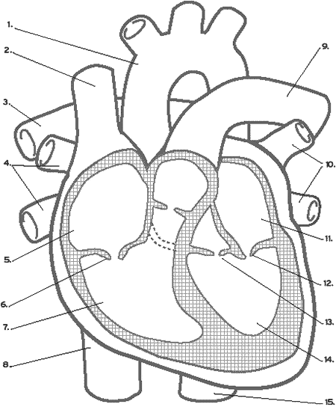

Circulation Through The Heart: (Find an animation on-ˇline that helps you visualize this)
(Trace the pathway of blood on the diagram above Blue =Deoxygenated Red =Oxygenated)
16. Blood enters via ___________________________ veins into the right ___________________
17. Through ____________________________ valve into right _____________________________
18. Through _________________________ valve into _____________________ arteries to lungs
19. Back from lungs via ________________________ veins into left ________________________
20. Through _____________________________ valve into left _____________________________
21. Through ________________________________________________ valve into aorta to body
22. What is the difference between your systolic and diastolic blood pressures?
23. What is the normal human blood pressure? ______ / ______
24. What is another name for hypertension? Define it in your own words.
25. A person with anemia has too few red blood cells. The most common symptom is a lack of energy. Why would anemia cause this symptom?
26. One function of the circulatory system is to help maintain a uniform body temperature. Explain how the constant circulation of blood through the body can accomplish this.

